V6Z80P + V1.1

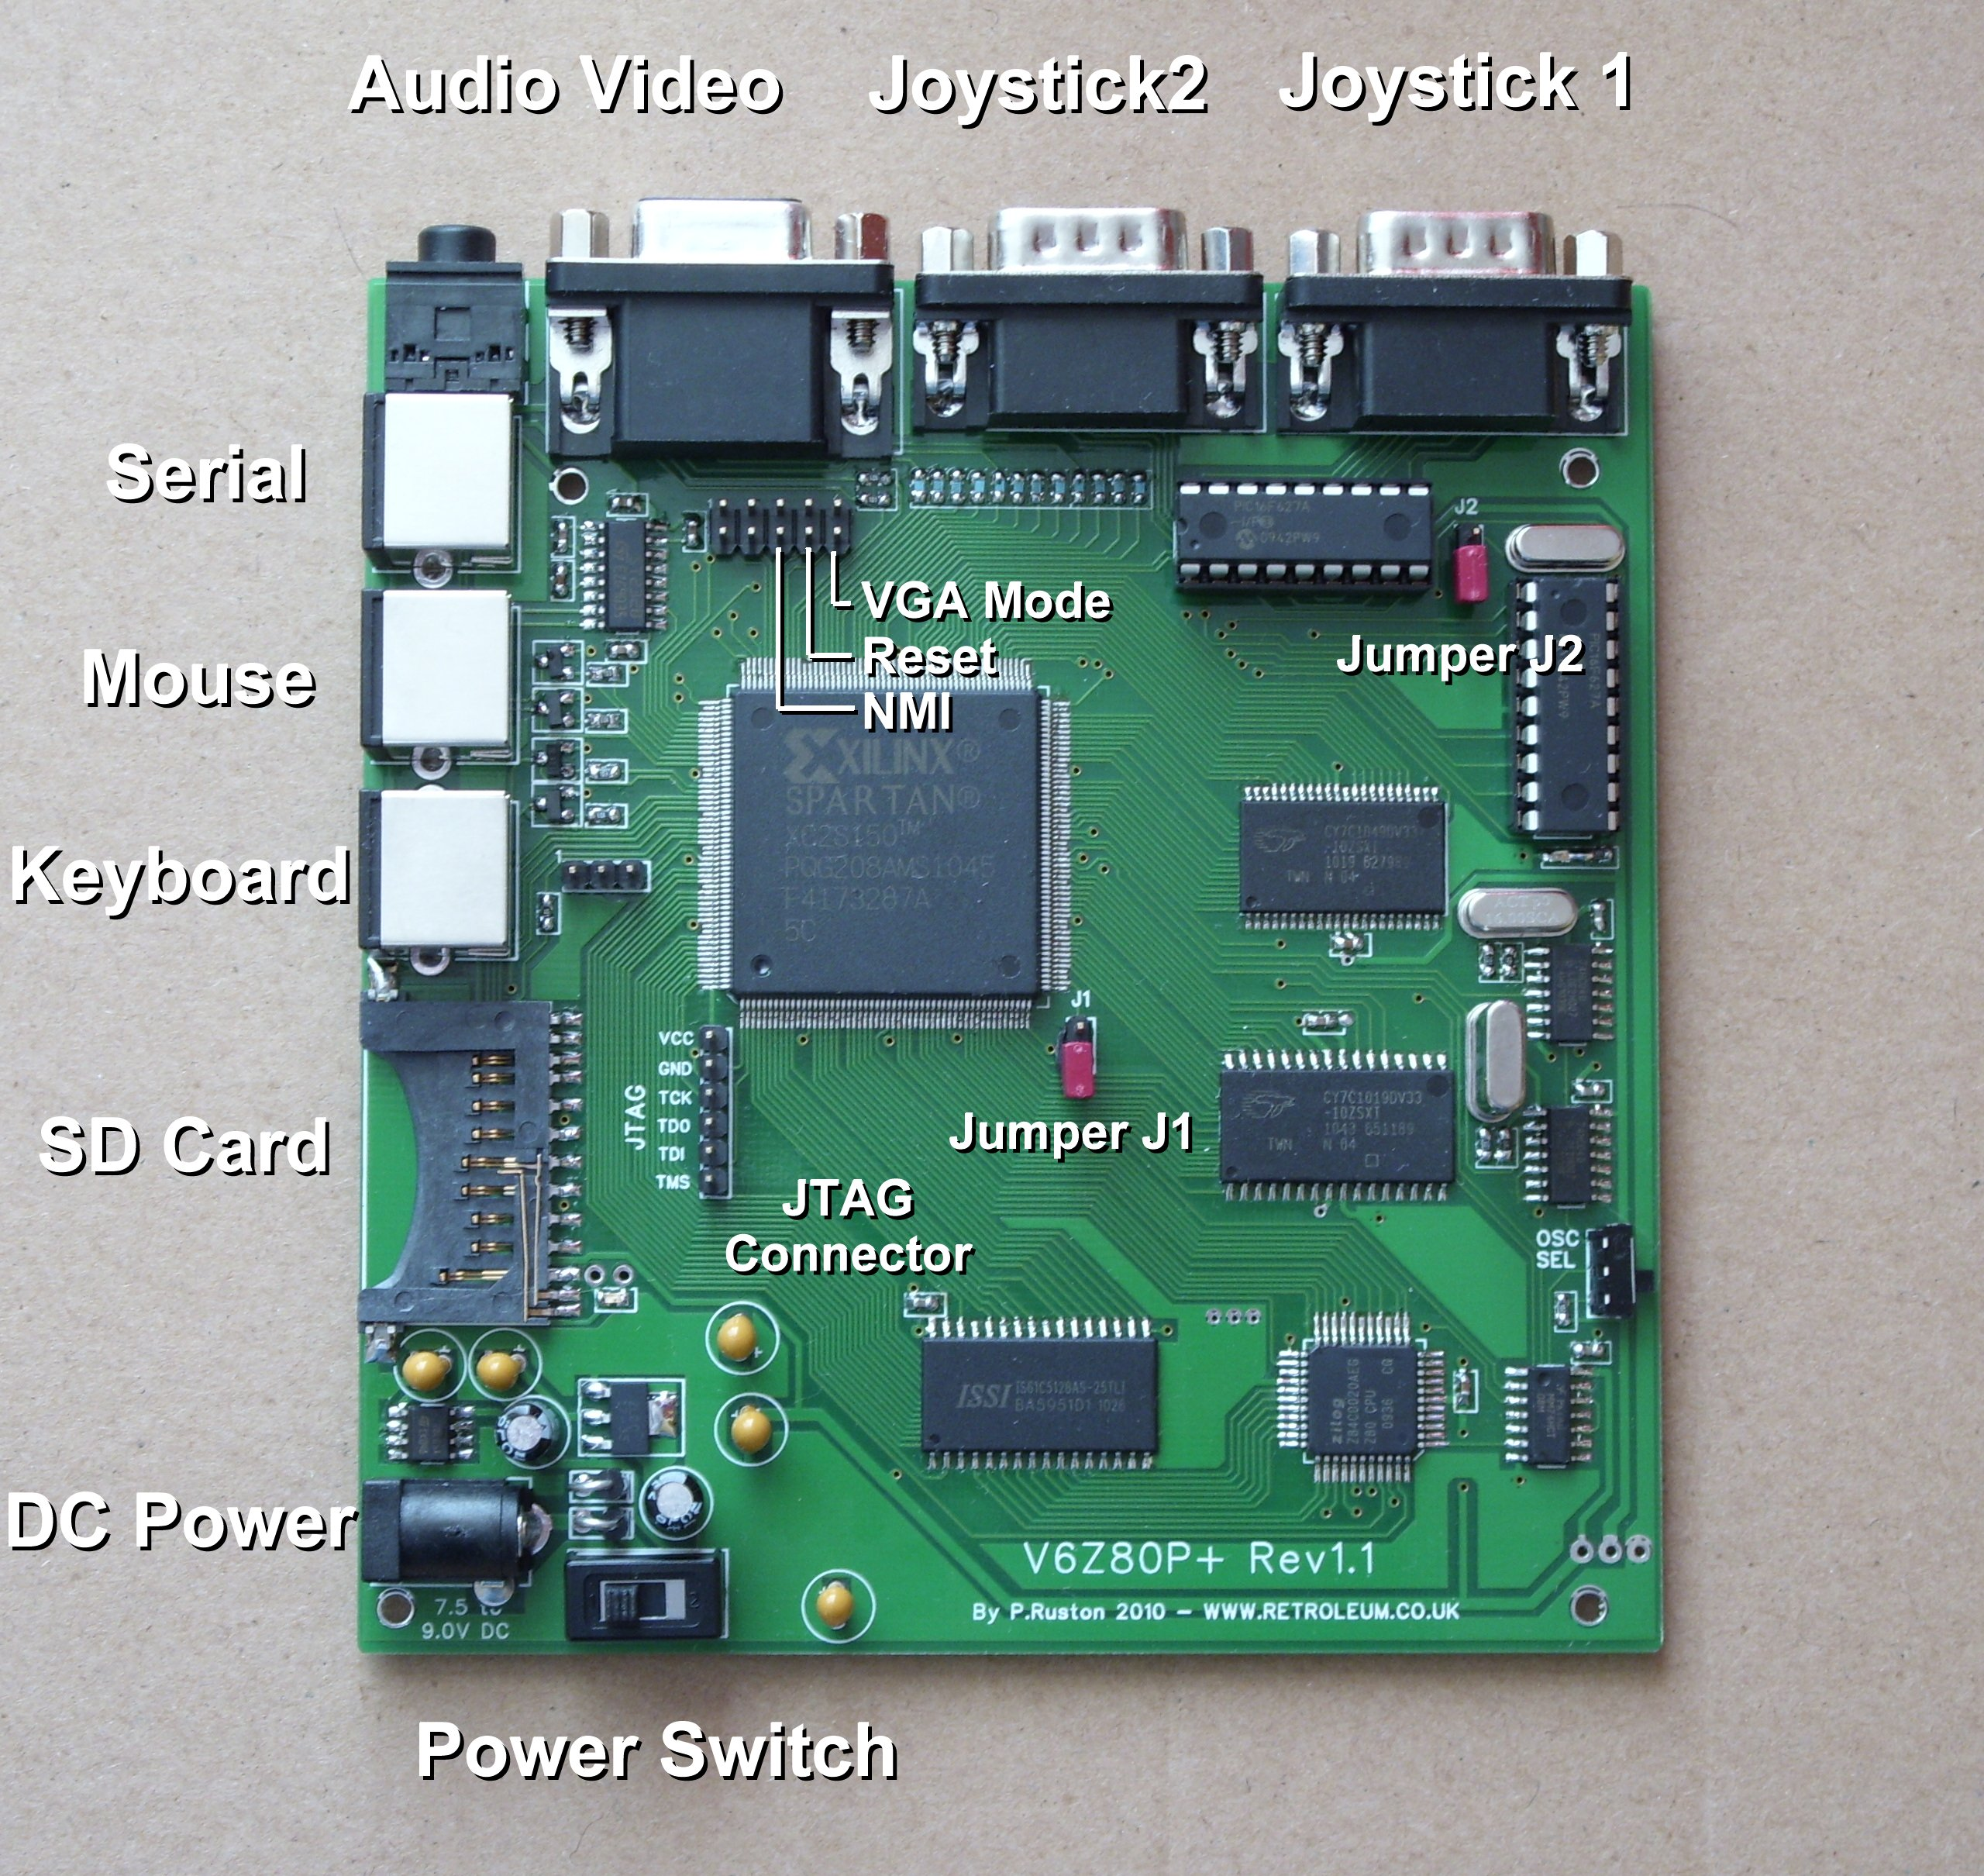

For the complete project archive / latest full documentation please visit:

wiki.retroleum.co.uk

Getting started - Basic Info

Basics:

The V6Z80P system - as supplied - comprises of 3 main elements:

1. The PCB itself, this is the actual "V6Z80P(+)" - (The "+" version is a revision of the original board; there is a standard 15pin D-Socket for video, slightly different connections to the FPGA chip etc.)

2. My default FPGA architecture design for the FPGA called "OSCA" (Old School Computer Architecture) held in the onboard EEPROM

3. My command line operating system called "FLOS" (Freezer-Like Operating System) held in the EEPROM and/or on SD card.

The V6Z80P requires a 7.5 volt (or 9 volt maximum) DC regulated mains adapter capable of delivering around 1 Amp or more. The jack plug should be 2.1mm type, centre-pin positive.

Starting out:

At a minimum, connect power, PS2 keyboard, video/audio cables, make sure the VGA-mode jumper (on the 10 pin header) is installed if using a PC monitor. The JTAG jumpers (J1 and J2) should be uninstalled for normal EEPROM-based start-up.

Download the full project archive from the wiki address above (to PC) then format an SD card to FAT16 (the card needs to be between 32MB and 2GB, please use a good brand to ensure compatibility). Copy the contents of the archive "Phils_SD_Card.rar" from the project archive to the card and insert into the V6Z80P's card slot. (You can use the V6Z80P without an SD card, but you'll need to download everything except the internal commands via serial comms).

Power on the V6Z80P with the switch near the DC power socket. The yellow LED should come on, the black and white boot-up display appears on screen and afterwards the OS loads (from SD card if present, or failing that from the onboard EEPROM). Once loaded, you can type "?" <return> for a list of internal commands.

Programs can be run from the SD card (use the command line to navigate in a similar manner to DOS) or downloaded into memory via serial comms from a Windows PC using the serial_link cable and utility provided. Most of the demos etc can be quit by pressing the ESC key.

Alternative configs:

The onboard EEPROM has "slots" for multiple FPGA configurations - on power-up the FPGA starts from whichever is the "Active Slot". As supplied, OSCA for 50Hz PAL TVs in Slot 1, OSCA for 60Hz NTSC TVs
is in Slot2 and a Spectrum 128 / 48 emulator is in Slots 3 (PAL). Slot 1 or Slot 2 will be the default Active Slot depending on location. (All the configs supplied support VGA output.)

The OSCA/FLOS Bootloader allows you switch to one of the other slots by tapping F1-F7 as the system starts up. EG: Tap F3 for the Spectrum Emulator (you can also use the FLOS command "BOOT" or the "EEPROM" configuration utility to reconfigure the FPGA).

Notes:

Avoid connecting or disconnecting anything to the V6Z80P whilst the power is switched on.

FLOS cannot automatically recognize card swaps and any card inserted whilst the power is on (not recommended) needs to be initialized with the "MOUNT" command. The card slot accepts MMC or SD cards (the code does not as yet support SDHC cards).

If your PC doesn't have a (free) serial port, a USB->RS232 adapter should work (I use one myself.)

Occasionally, the first time the serial link util is used, the first file transfer fails with a "bad acknowledge" report. (I've yet to find out exactly why..)

